Level 30 -> Level 31

The goal of this level is to access **a git repository at ssh://bandit30-git@localhost/home/bandit30-git/repo.** The password for the user bandit30-git is the same as for the user bandit30. We need to clone the repository at our local computer and find the password for the next level.

This level is same as level 28,29,30. Follow first three steps of level 28/29/30.

Steps to follow after completing first three steps:

1. Check the files present in repo.
2. README.md file is present. When we cat README.md file we found a text “just an empty file… muahaha”
3. Check for the branch if present. But no branch present.
4. Tags may be present. Tag operation allows giving meaningful names to a specific version in the repository. Check for the tags using **command git tag.**
5. One tag is present and named as **secret.** It may give us the password. Use **command git show secret** to display what content is tagged.
6. Our password was tagged as secret.

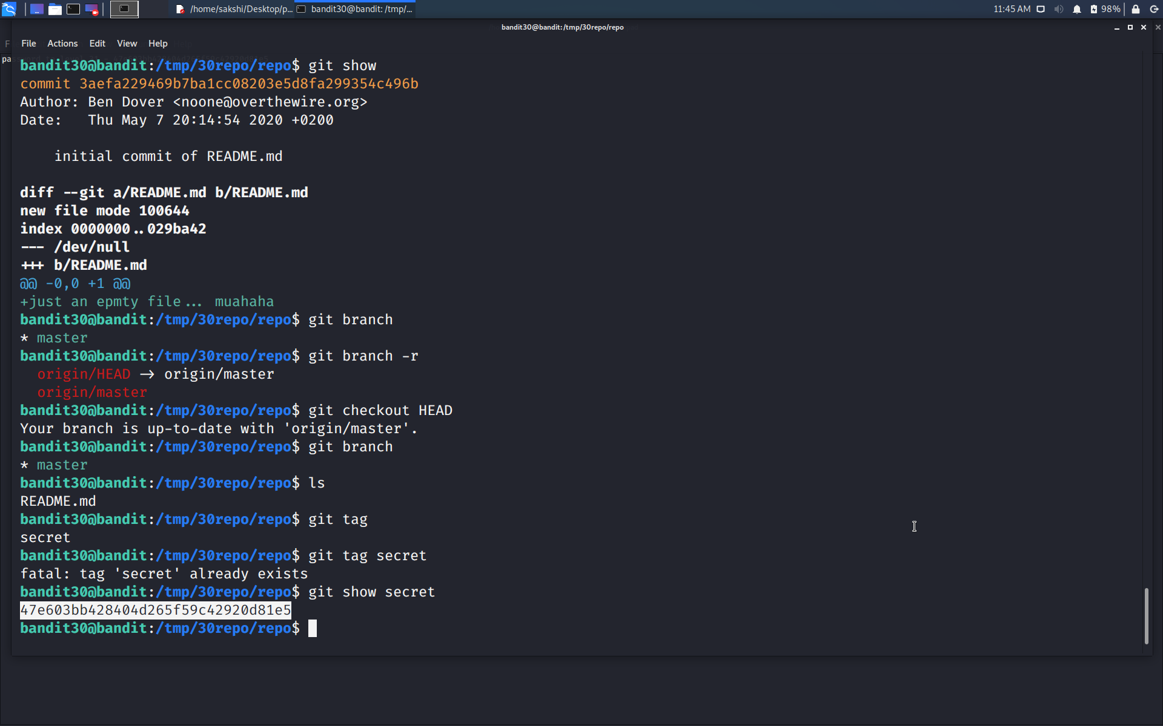

Use the command **ssh bandit31@localhost** to connect to the level 31.

Enter the password and hit enter.

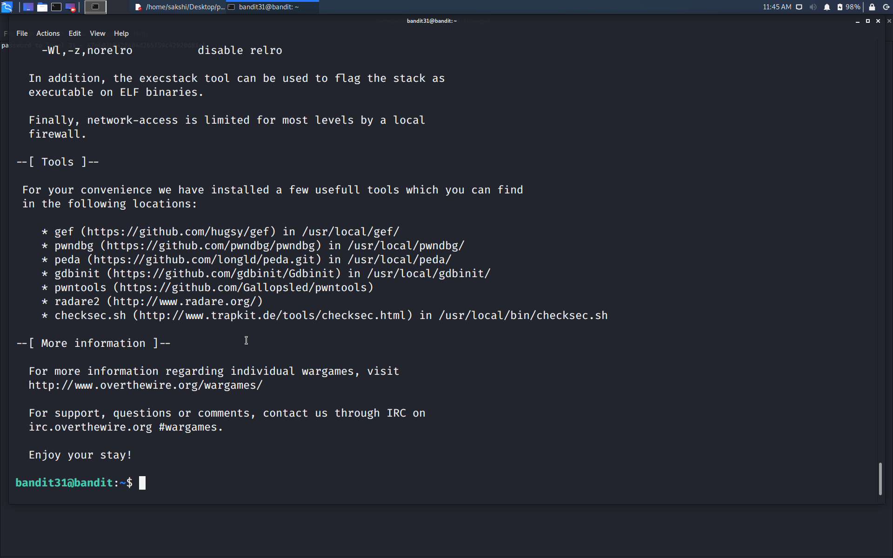

Successfully passed level 31.…